Notes from Post Week 1 Emcee-GA March 4th training call

Lots of great REEFSCAPE game play and process reports from Week 1 events. Thanks to all.

Alliance Selection
Please use the NEW and UPDATED Alliance Selection Script in the Resource Library
- Emcees will now stand on the BLUE SIDE of the FIELD.
- Emcees must follow the exact wording of the Alliance Selection Script so you align with your FTA.
- There will be two 2 Field Assistants – 1 on the field, 1 at the gate to help usher teams.
- The Round 1 Alliance Captains will walk onto the field and approach the Emcee when they are ready to announce their pick, then will be moved to their position on the field.
- The on-field Field Attendant may have teams use the gates instead of going under the truss, although both paths are acceptable.
- Rule T601 states that if a team is not present for the Alliance Selection when they are announced, they are disqualified from the Playoff Tournament
- Team Placement:
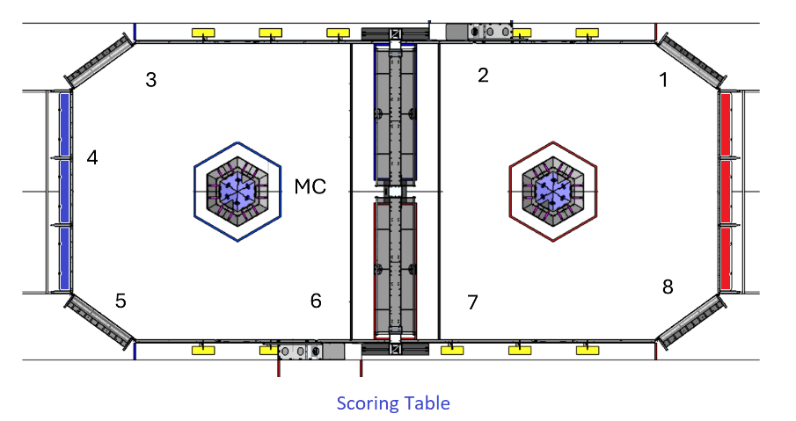
General Notes
- Emcees may elect to go under or around the truss.
- 8 min cycles is the goal- some events achieved, some did not.
- Begin team intros a bit sooner than previous years as the radios are quicker once they begin linking up.

