Feel free to add branding to this document to make it align with the team’s documents. This is only a rough guideline as an example.

***FIRST*Robotics Competition**

**Team XXXX**

**Business Plan**

# Mission Statement:

Please briefly indicate what you believe to be the “driving engine” of your team. Your mission should be clear and concise. It should represent to any reader exactly what your team strives to accomplish.

# Team History and Growth:

Please briefly highlight where your team is from and how your team has grown and/or manage turnover with emphasis on the past 2 years.

# Organizational Structure:

Please detail how your team operates and how you continue to grow your program with emphasis on the next 2 years.

# Risk Analysis:

Please describe how your team deals with risks and opportunities. Also describe your team’s strengths. Consider using a SWOT (Strengths, Weaknesses, Opportunities, and Threats) Analysis to show this.

# Marketing:

How do you get your team/brand out there and create engagement?

# Financials:

Please include information on team finances (include details on income statement and balance sheet as an appendix). How is your team funded and how do you budget? Please also briefly highlight your relationship with your sponsors and how you recognize them.

# Appendix 1 – Organizational Chart

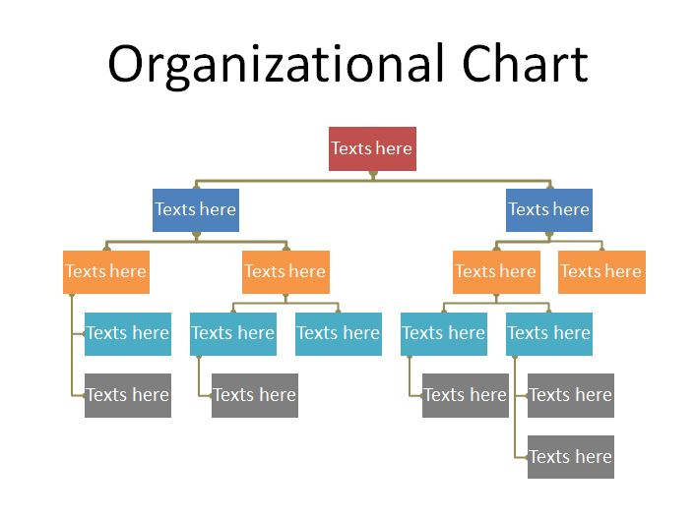

# Appendix 2 - SWOT Analysis



# Appendix 3 - Financials

**Income Statement**

|  |  |  |
| --- | --- | --- |
| Revenues |  |  |
|  | $ XXXX.XX |  |
|  | $ XXXX.XX |  |
|  | $ XXXX.XX |  |
| Total Revenues: |  | $ XXXX.XX |
| Expenses |  |  |
|  | $ XXXX.XX |  |
|  | $ XXXX.XX |  |
|  | $ XXXX.XX |  |
|  | $ XXXX.XX |  |
|  | $ XXXX.XX |  |
| Total Expenses: |  | $ XXXX.XX |
| Net Income |  | $ XXX.XX |

**Balance Sheet**

|  |  |  |
| --- | --- | --- |
|  | 2023 | 2024 |
| Assets |  |  |
|  | $ XXXX.XX | $ XXXX.XX |
|  | $ XXXX.XX | $ XXXX.XX |
|  | $ XXXX.XX | $ XXXX.XX |
|  | $ XXXX.XX | $ XXXX.XX |
| Total Assets | $ XXXX.XX | $ XXXX.XX |
| Liabilities |  |  |
|  | $ XXXX.XX | $ XXXX.XX |
|  | $ XXXX.XX | $ XXXX.XX |
|  | $ XXXX.XX | $ XXXX.XX |
|  | $ XXXX.XX | $ XXXX.XX |
|  | $ XXXX.XX | $ XXXX.XX |
|  | $ XXXX.XX | $ XXXX.XX |
| Total Liabilities | $ XXXX.XX | $ XXXX.XX |